AWS INTERVIEW QUESTIONS

1. Define and explain the 3 basics types of cloud services? And aws product that are build based on them

>>> 1) Compute ---> it help to run any application and managing

Scaling and deployment of application

Product ---> EC2, Elastic Beanstalk, Lambda, Auto-Scaling

and Lightsail

2) Storage ---> Store data and information of application .

Product ---> S3, Glacier, Elastic Block Storage, Elastic file

System

3) Networking ---> Control and manages the connectivity of aws

Services and we can choose your own ip address range

Product ----> VPC, CloudFront, Route53

1. What is relation between Availability Zone and Regions?

>>> AWS Region is separate geographical area eg. Mumbai Region

Region does replication between them but Availability zone do.

Aws Availability zone is logical data centre and AZs are distinct location within region

1. What is Auto-scaling?

>>> It helps to automatically increase and decrease capacity whenever there is demand. It is main reason to use AWS.

It is use for controlling and managing server.

1. What is Geo targeting in CloudFront?

>>> Geo Targeting is nothing but CloudFront will detect the use’s country of origin and pass along the country code to origin server.

You can use this information to customize/modify your responses without using URLs that are specific to each country.

1. Steps of CloudFormation solution?

>>> 1) create cloudformation template (YMAL or json file format)

2) Save the code in S3 bucket it serves as repository

3) From cloudformation call file in S3 bucket and create stack

4) Cloudformation uses the file, reads the file ,understand

Services which are called and order also.

1. How do you upgrade and downgrade a system with 0 downtime?

>>> Upgrading new system with 0 downtime it include launching another system parallel with bigger ec2 instance type over the bigger capacity and install all that’s needed. If your are going to use an AMI of old machine then well and good you don’t have to go through installing all the updates and application from the AMI once you launched it in a bigger instance. Test the application when its working.

If your are using static ip then you can remove static ip from old machine and assign it to new machine

If your using elastic nic card you can remove it from old machine and

Attach to the new machine

1. What are all the tools and techniques you can use in AWS to identify and correct if you are paying more than you should be?

>>> 1) Top Free tier Services Table

>> This is dashboard of billing and cost management console.

>> Its shows top most free tier services usage.

>> It should be paid or free tier services.

2) Cost Explorer

>> This allows you view and analyse the cost.

>> You can view the cost from last 13 months.

>> You can also get cost forecast for coming 3 months.

3) AWS Budgets

>> You can plan your services usage, service cost and instance

Reservation.

>> If it exceeds your budgets then you would get an alarm.

>> You can view current plan meeting your budgets and usage

Details.

4) Cost Allocation Tags

>> You can identify which team or resource has more usage.

>> You can stop users using more services.

>> Cost allocation tags to track your AWS costs on a detail level.

>> You can assign label to AWS resource.

>> Each tag has key and value.

1. Are there any other alternate tools to log into cloud enviroment other than CONSOLE?

>>> 1) Putty

2) AWS CLI for Linux

3) AWS CLI for Windows

4) AWS CLI for windows CMD

5) AWS SDK

6) Eclipse

1. What services can be used to create a centralized logging solution

>>> The Centralized Logging solution enables organizations to collect, analyze, and display Amazon Cloud Watch Logs in a single dashboard.

Centralized logging provides two important benefits. First, it places all of your log records in a single location, greatly simplifying log analysis and correlation tasks. Second, it provides you with a secure storage area for your log data.

It also helps you to understand the infrastructure.

1) Amazon CloudWatch Logs

2) Amazon Kinesis Firehose

3) Amazon S3

4) Amazon Elastic Search

1. What are the native AWS Security logging capabilities?

>>> Following services have their own logging.

1) AWS CloudTrail

2) AWS Config

3) AWS CloudFront

4) AWS Redshift

5) AWS RDS

6) AWS VPC

7) S3

1. What are DDoS attack and what services can minimize DDoS

Attacks? (Distributed Denial of Service)

>>> Denial of services is cyber-attack, this attack is meant to

Shutdown machine or network, making it inaccessible to its

Intended users.  **Flood attacks** occur when the system receives too

Much traffic for the server to buffer, causing them to slow down

And eventually stop.

Distributed Denial of Service is attack is where multiple systems

Target a single system with a DoS attack.

**Distributed denial-of-service attacks** target websites and

Online services.

A DDoS attack is an attempt to make website or application

Unavailable to genuine user, this achieve by hacker using various

Method that completely consume network or resources

Services which are help to minimize DDoS attack

1) AWS Shield

2) AWS WAF

3) AWS Route53

4) CloudFront

5) Elastic Load Balancer

6) VPC

1. You are trying to service in particular region but you are not

Seeing this service in that region, how to fix it?

>>> As of now, not all services are available in all regions. This is

Because high infrastructure and maintenance tax

When amazon announce new service then they don’t immediately publish on all region and as per as demand of region they slowly move to anther service.

1. How do you setup a system to monitor website metrics in real-time in AWS?

>>> AWS CloudWatch --- It help us to monitor application status of

Various AWS services and custom events

Using CloudWatch we can monitor

* State changes in AWS EC2
* Auto scaling lifecycle event
* Scheduled Event
* AWS api calls
* Console sign-in event

CloudWatch has 3 statuses Green, Yellow and Red.

Green >> when everything is going good

Yellow >> when the services is degraded, it call to lambda

Function to debug application to fix it.

Red >> when services is not available, notify to owner of

Application about the services is down.

1. What are the different of virtualization and what is the difference between them?

>>> Virtualization is a technique of how to separate a service from the underlying physical delivery of that service. It is the process of creating a virtual version of something like computer hardware.

There are 3 different types of virtualization

1) Hardware Virtual Machine --- Fully virtualized set of hardware

HVM (known as **Hardware Virtual Machine**) is the type of instance

That mimics bare- provides better metal server setup which

Hardware isolation.

2) Paravirtulization (PV) --- **Paravirtualization** (PV) is an

Enhancement of virtualization technology in which a guest

Operating system (guest OS) is modified prior to installation inside

A virtual machine (VM) in order to allow all guest OS within the

System to share resources and successfully collaborate

3) Paravirtulization on HVM (PV on HVM) --- **PV on HVM** is a mixture

Of  paravirtualization and full hardware virtualization. The primary

Goal of **PV on HVM** is to boost performance of fully Virtualized

**HVM** guests through **use** of specially optimized paravirtual device

Drivers.

1. Name some AWS services which are not region specific?

>>> Global Services or Not region specific services

1) IAM --- IAM user, accounts and roles can be used globally

Across the region.

2) Route53 --- it offered services at AWS edge location and are

Global.

3) Web Application Firewall --- it protects web application from

Common Web exploits are offered at AWS edge location and

Are global.

4) CloudFront --- it global content delivery network which is

Offered at AWS edge locations.

1. What are differences between NAT Gateway and NAT instance?

>>> **NAT Gateway** is a highly available **AWS** managed service that

Makes it easy to connect to the Internet from instances within a

Private subnet in an Amazon Virtual Private Cloud.

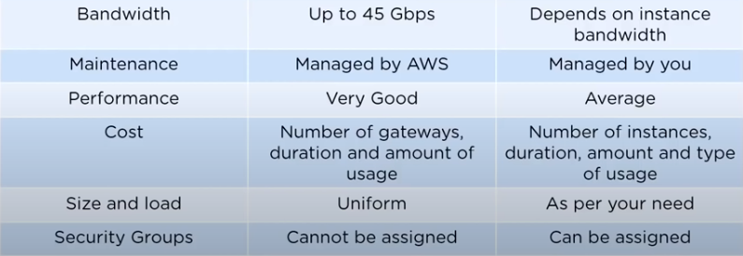

1. What is difference between stopping and terminating an EC2

Instance?

>>> Stopping instance is normal shutdown on instance and move to

Stopped state. And Terminating instance is you can't connect to

Or start an **instance** after you've **terminated** it.

1. What are the different types of EC2 instance based on their costs?

>>> 1) On-demand instance --- These EC2 instance are that are

Purchased at fix rate per hour. This are use for short-term

Workload and it suited for develop and testing application

2) Spot instance --- A **Spot Instance** is an **instance** that uses

Spare EC2 capacity that is available for less than the On-Demand

Price and price of the spot instance will vary on based on supply

And demand of market

3) Reserved Instance --- Reserved instance are majorly used for

Short-term and they are cost saving for companies, and there is

No upfront payment.

1. How to setup SSH agent forwarding so that you do not have to

Copy the key every time you login?

>>> Steps to SSH agent forwarding

1) Go to your PuTTY configuration.

2) Go to category SSH -> Auth

3) Enable SSH agent forwarding to your instance.

1. What are the Solaris and AIX operating system? Are they available

On AWS?

>>> Solaris uses SPARC architecture which is not supported in public

Cloud currently

AIX runs only on Power CPU and not on Intel Hence you cannot

Build AIX instance in EC2 instance

1. How do you configure CloudWatch to recover EC2 instance?

>>> 1) you can create Alarm using Amazon CloudWatch.

2) In this Alarm go to Define Alarm -> Action tab

3) Select Recover This Instance option.

1. What are the common and different types for AMI designs?

>>> 1) Fully Baked AMI --- these are simplest to deploy and provide

The fastest launch time.it is for small AWS deployment and it

Can be expensive.

2) Just Enough Operating System AMI (JeOS) --- This has minimal

Operating system that is fully functional system at its launch.

They offer more flexibility during deployment and giving

Highest level of portability

3) Hybrid AMI --- they fall between fully baked AMI and JeOS

These AMIs have a partially baked generic infrastructure on

Top of which you can install required s/w based on

Requirement

1. How can you recover/login to an EC2 instance to which you lost

The key?

>>> Following steps recover /login to EC2 instance

1) Verify that the EC2Config service is running.

2) Detach the root volume from the instance.

3) Attach the volume to another instance / temporary instance.

4) Modify the Configuration file.

5) Restart the original instance.

1. What are some key difference between AWS S3 and EBS?

>>> 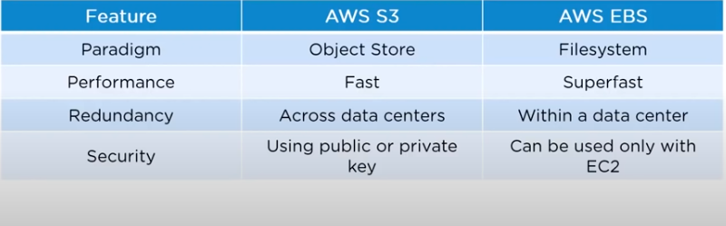

1. How do you allow access to a user to a certain bucket

>>> Steps to allow access to certain bucket

1) Categorize your instance.

2) Define how authorized user can/can’t manage specific server.

3) Define tag

4) Attach your policies to IAM users.

1. How can you monitor S3 cross region replication to ensure

Consistency without actually checking bucket?

>>> Cross Region Replication Monitor (CRR Monitor) application is

Used to monitor replication status of your Amazon S3 object.

1. VPC is not resolving the server through DNS? What might be

Issue and how fix it?

>>> Enable DNS hostname option which is available in while creating

VPC.

1. How do you connect multiple sites to a VPC?

>>> We can connect multiple sites by CloudHub.

**CloudHub** allows your remote sites to communicate with one

Another over VPN tunnels that are created between your

**AWS**  Virtual Private Gateway (VPG) and your remote sites.

1. Name and explain some security product and features available

In VPC?

>>> 1) Security Group --- Act as firewall for associated Amazon EC2

Instance, controlling both inbound and outbound traffic at

Instance level.

2) Network Access Control List (NACL) --- Act as firewall for

Associated Amazon VPC subnet, controlling both inbound and

Outbound traffic at subnet level.

3) Flow logs --- Capture information about ip traffic going to and

From network interface in your VPC.

1. How do monitor Amazon VPC?

>>> You can monitor Amazon VPC using the following

1) CloudWatch and CloudWatch logs --- It monitor application

And system using log data.

2) VPC Flow logs --- It is a feature that enables you to capture

You to capture information about the ip traffic going to and

From network interface in your VPC.

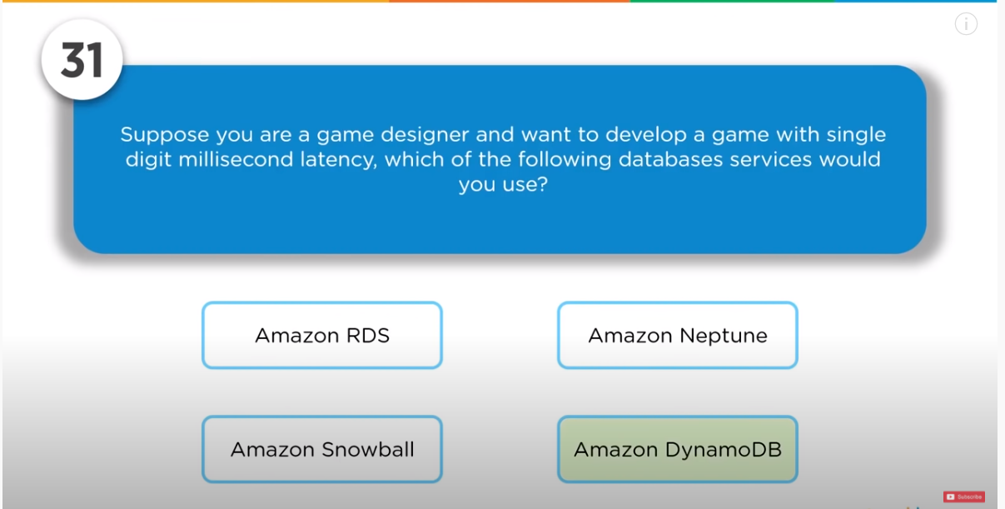

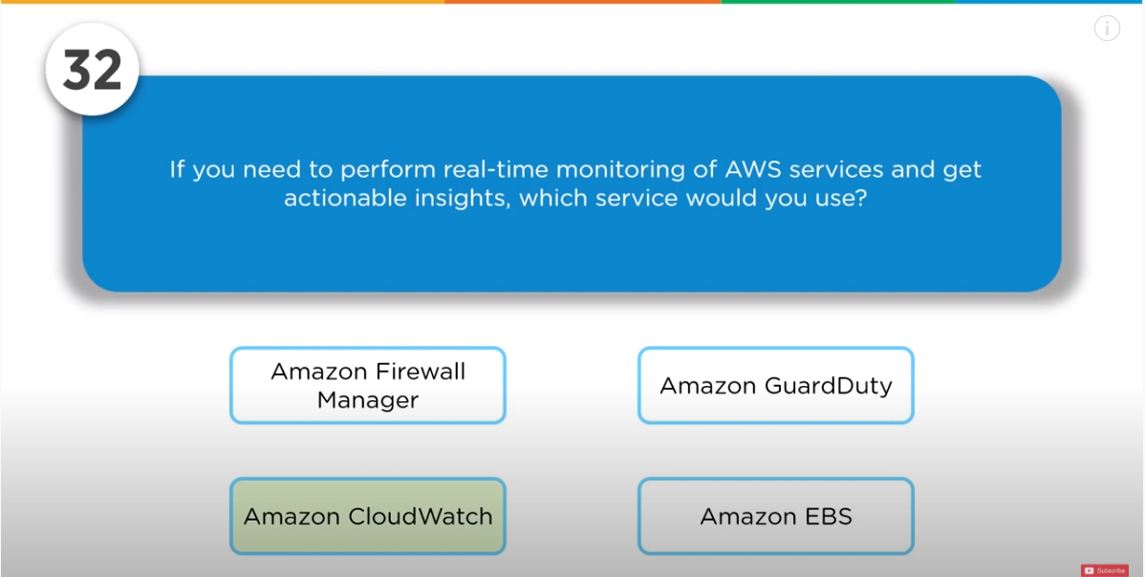

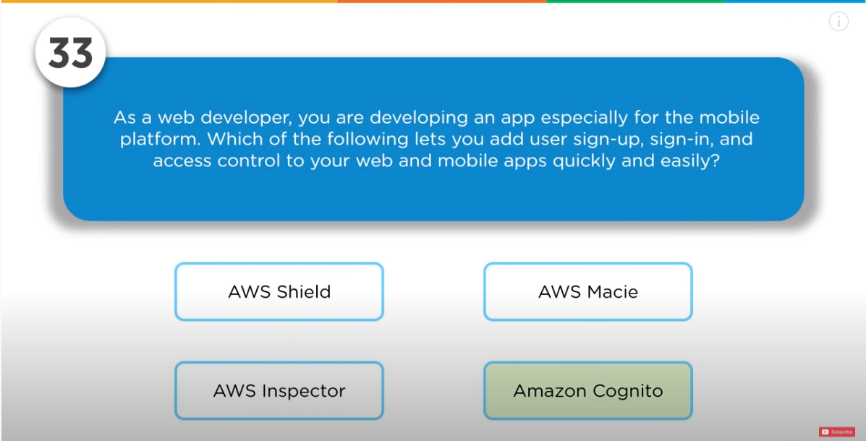

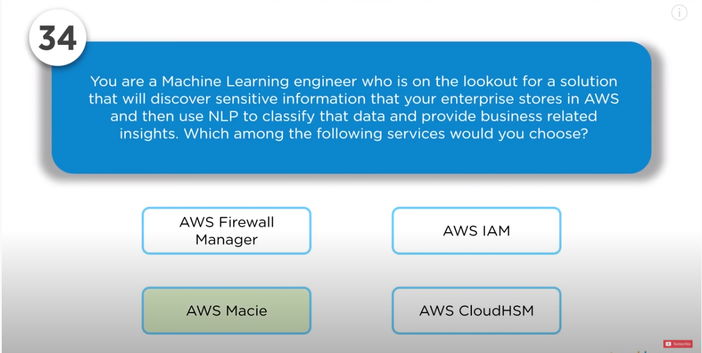

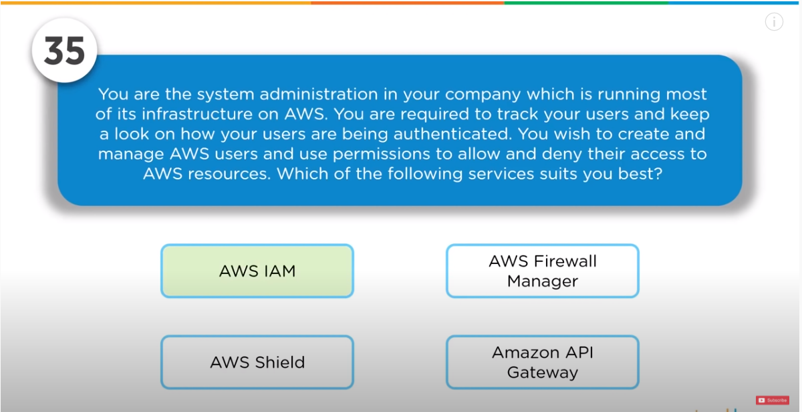

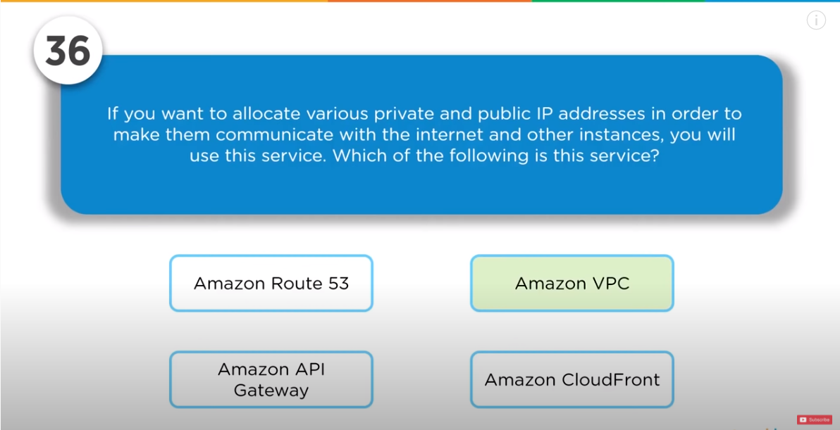

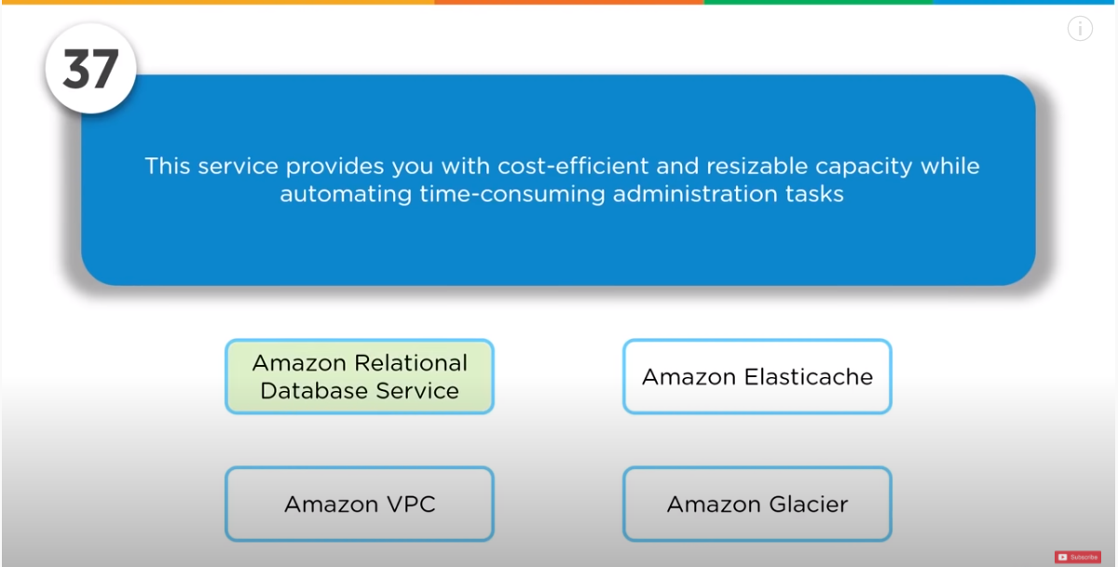

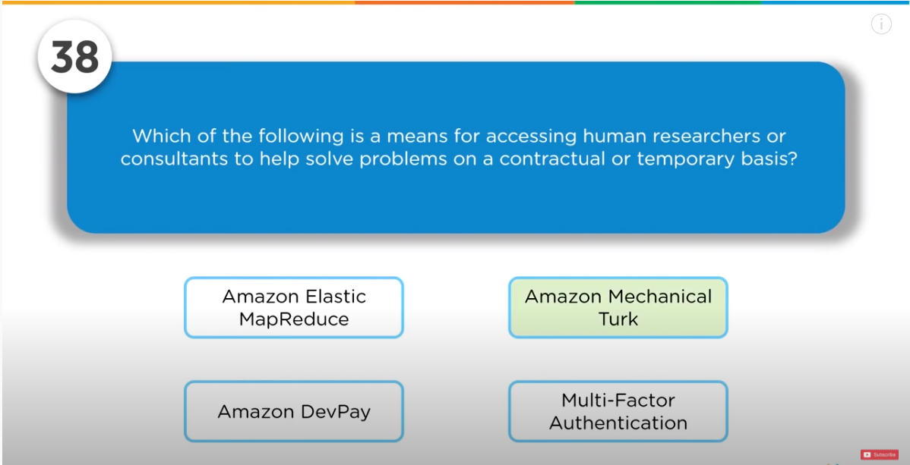

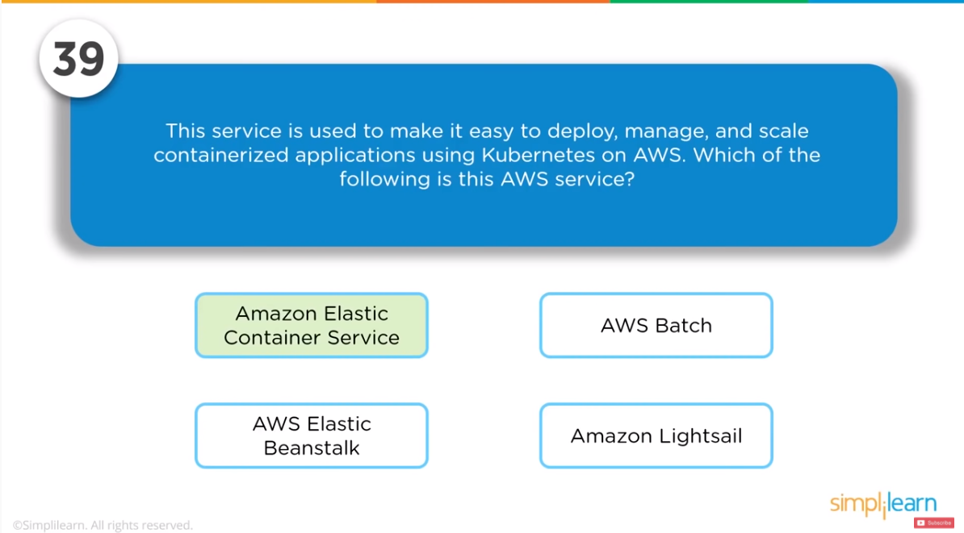

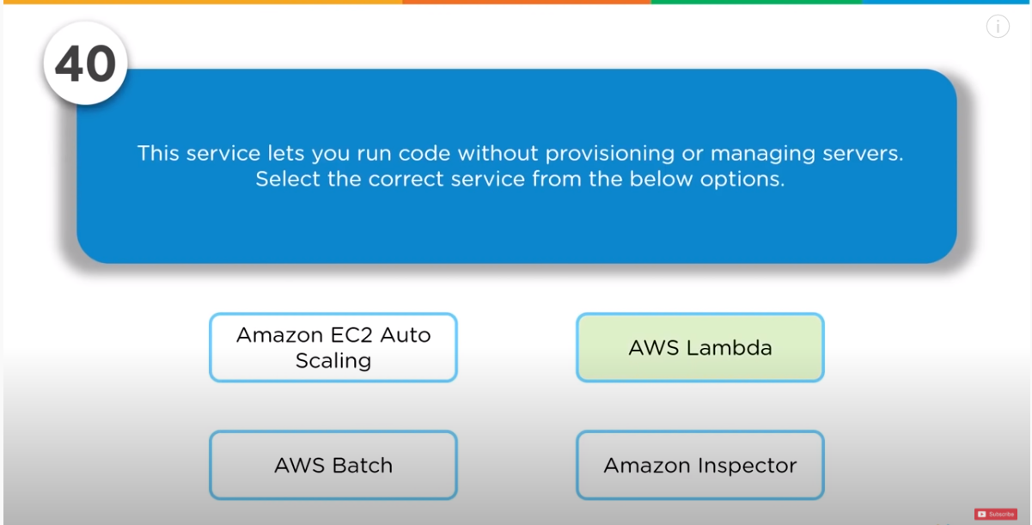

1. How do you add an existing instance to a new Auto Scaling

Group?

>>> Steps of adding new Auto Scaling group

1) Open EC2 instance select your instance under instance

2) Action >> Instance Settings >> Attach to Auto Scaling Group

3) Select a new Auto Scaling group

4) Attach this group to this instance

5) You can edit the instance if you needed

1. What are RTO and RPO in AWS?

>>> These are Disaster Recovery Terms

1) Recovery Time Objective (RTO) --- Maximum Time Company is

Willing to wait for the recovery to finish.

2) Recovery Point Objective (RPO) --- Maximum Amount of data

Loss you company is willing to accept the as measured in time.

1. If you would like to transfer huge amount of data, which is the

Best option along Snowball, Snowball Edge and Snowmobile?

>>>

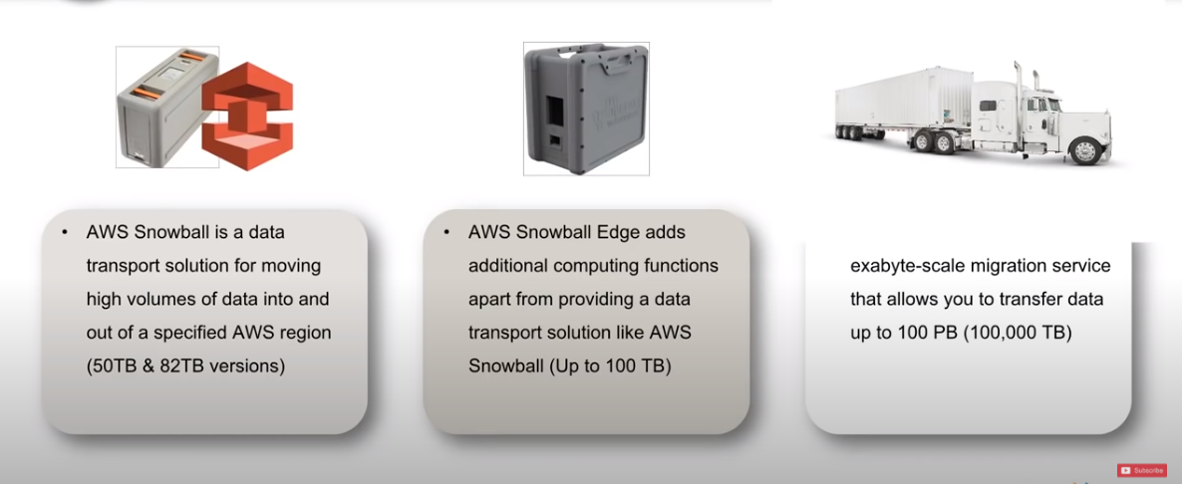

1. How is AWS CloudFormation different from AWS Elastic

Beanstalk?

>>>

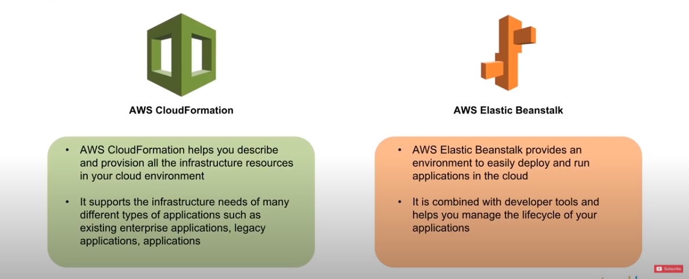

1. What are the different parameter of CloudFormation

>>>

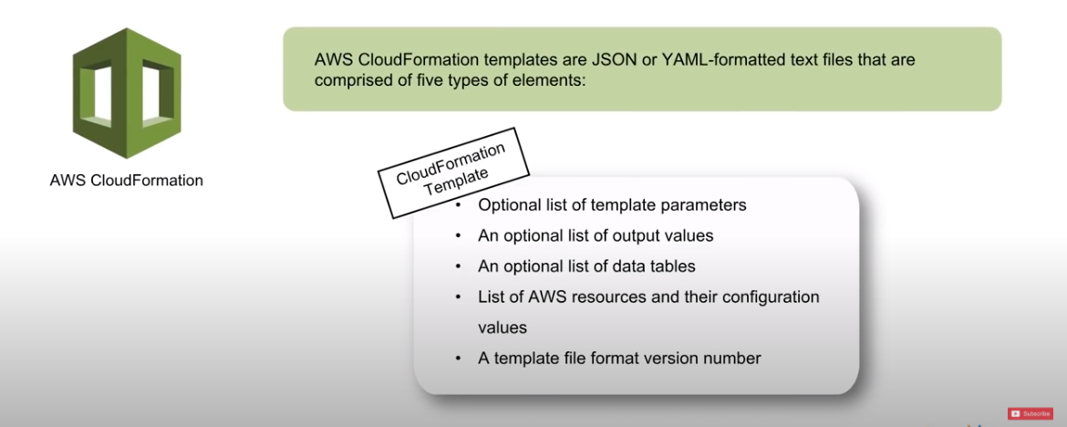

36 What happen when one resource in stack cannot be created successfully?

>>> CloudFormation rolls back and terminate all resources that was created, it delete all resources till the point where error occur and CloudFormation cannot created addition resources because we have reach elastic ip limit ( 1 region -5 ip). If AMI is not present then CloudFormation search for that and delete all resources.

37 How can you automate EC2 backup using EBS?

>>>

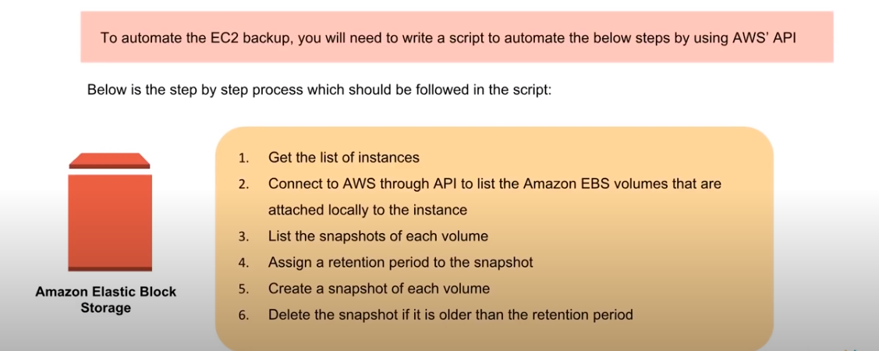

38 What is difference between EBS and Instance Store?

|  |  |
| --- | --- |
| EBS | Instance Store |
| Permanent Storage | Temporary Storage |
| We can detach from 1 instance and attach to another. | We cannot detach from 1 instance and attach to another. |
| Data is not loss when disk fail. | Data is loss when disk fail. |

39. Can you take backup of EFS to EBS? If yes, how?

>>> 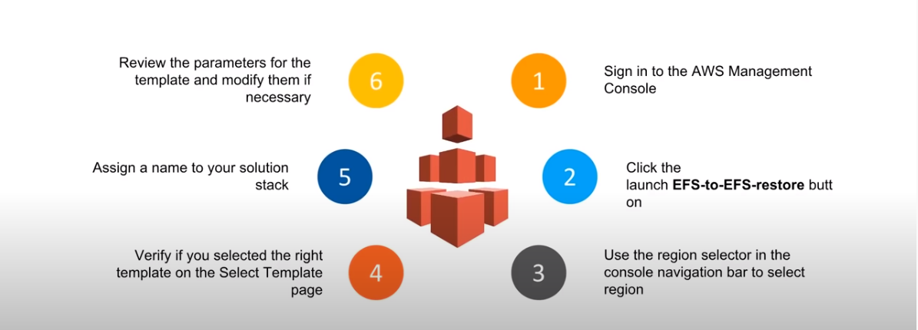

40. How do you auto delete old snapshot?

>>> 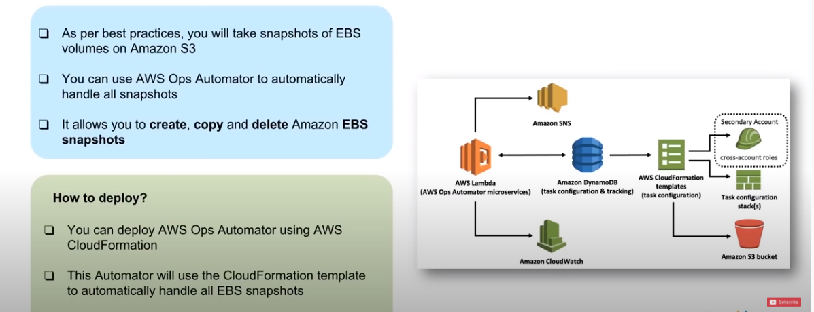

Base on retention period we can delete old snapshot by set as delete snapshot which are older than retention period.

41. What are different types of load balancer?

>>> There are 3 types of Load Balancer ---

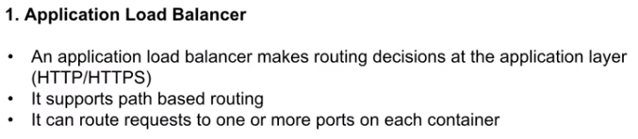

Path based routing -- .com slashes

Port based --- 8080, 8089 port, it can take routing decision.

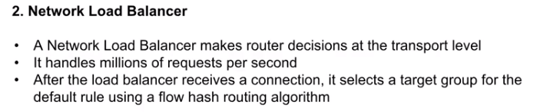

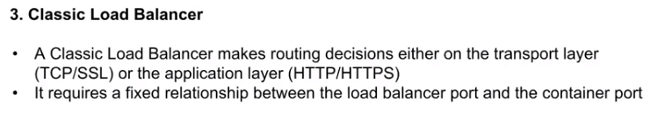

It is the first load balancer in AWS load balancer

42. What are the different usages of various types ELB?

>>>

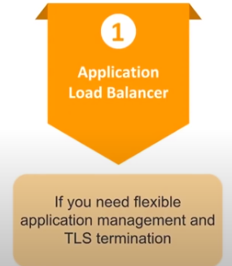 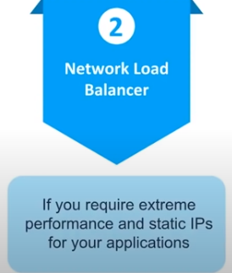 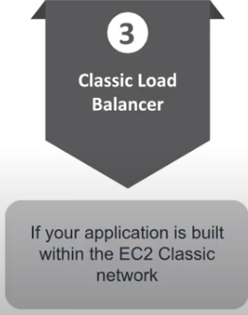

43. How can you use AWS WAF in monitoring your AWS application?

>>>

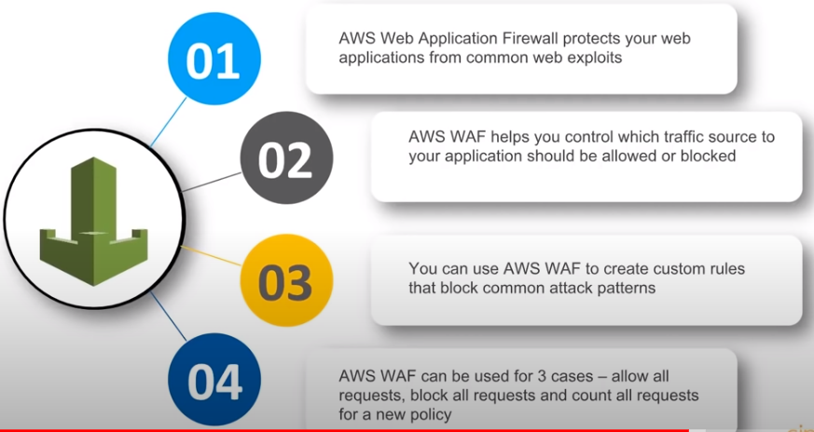

44. What are different AWS IAM categories you can control?

>>> 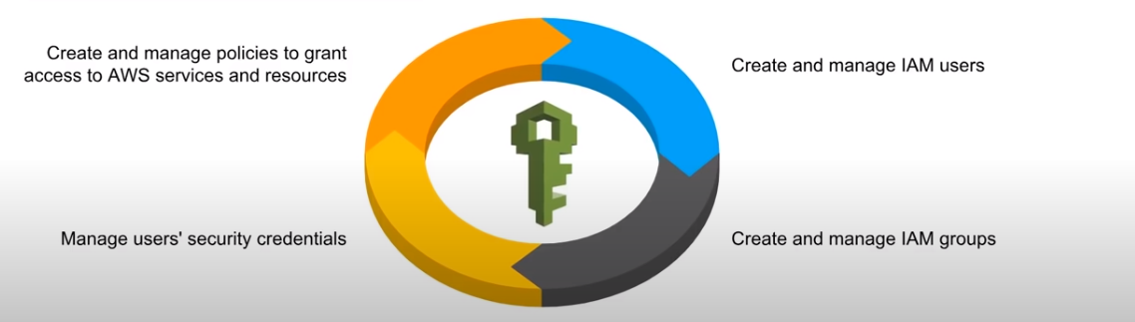

45. What are the policies that you can set for your users password?

>>>

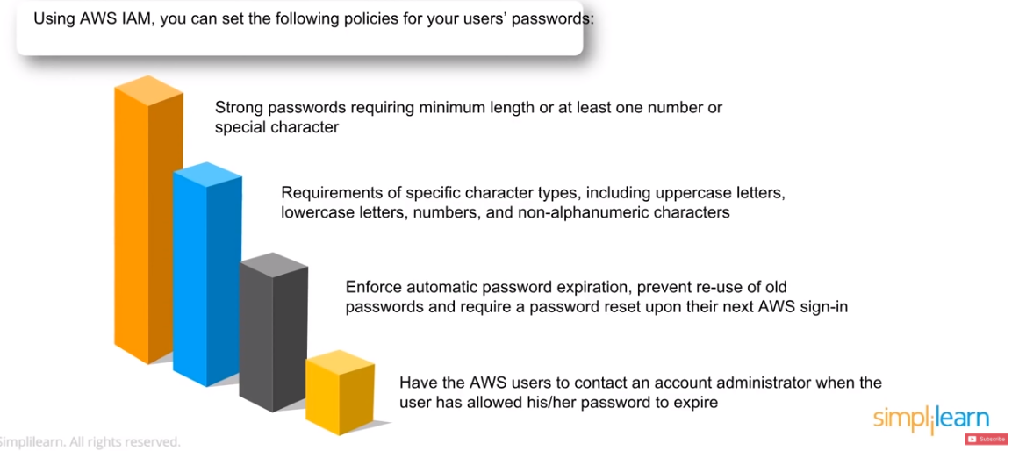

46. What is the difference between IAM role and IAM users?

>>> 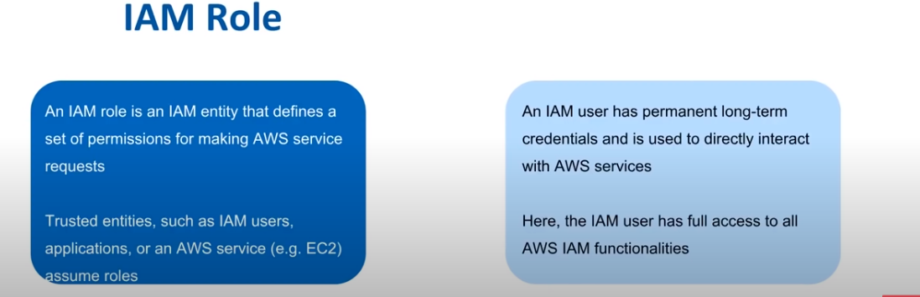

47. What are the IAM policies in AWS IAM?

>>> 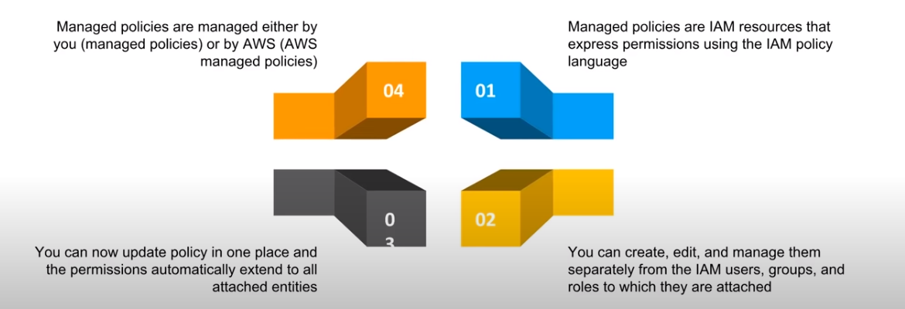

48. Example of IAM policy and summary

>>>

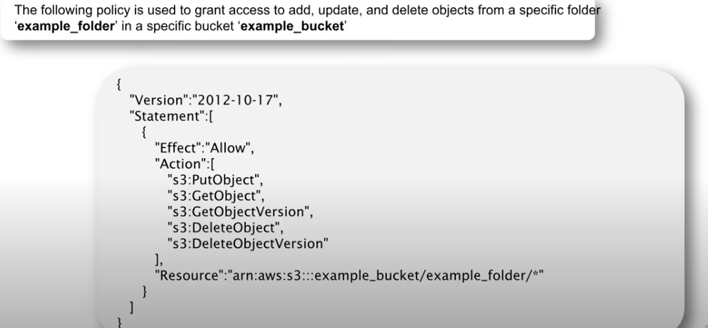

49. How does AWS IAM help your business?

>>>

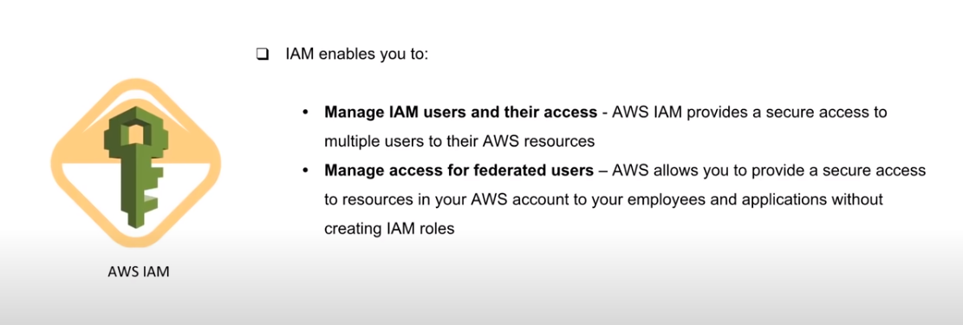

50. What are the difference between latency based routing and Geo DNS?

>>> Geo DNS --- It takes routing decision based on geographic location and it use when we want direct customers to different website based on country they are browsing from

Latency Based routing --- It uses latency measurement between network and data centers and it use when you want give lowest latency to customer as possible

51. What are the difference between Domain and a Hosted Zone?

>>>

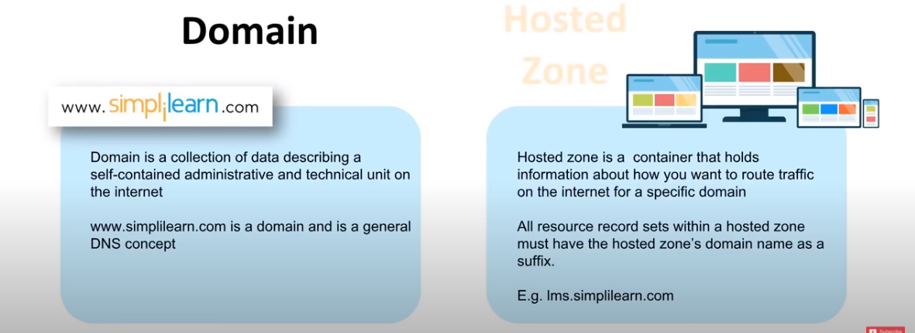

54. How does AMAZON Route 53 provide high availability and low latency?

>>> 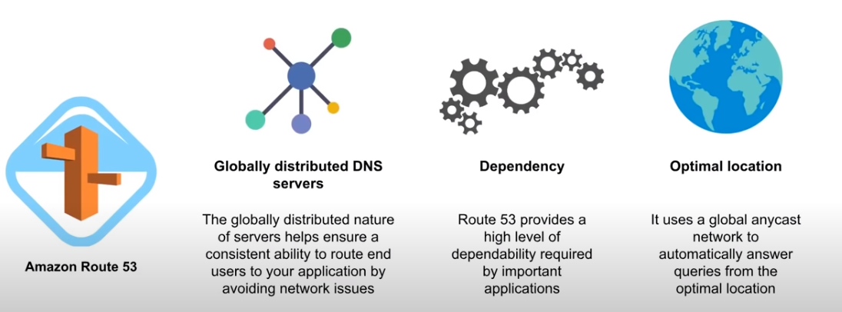

55. How does AWS Config work along with AWS CloudTrail?

>>>

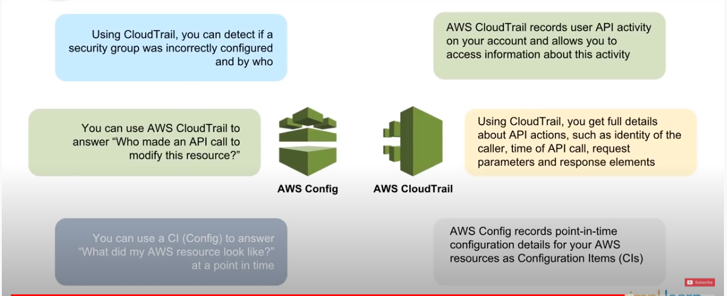

56. Can AWS Config aggregate data across different AWS Accounts?

>>>

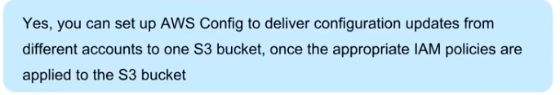

AWS Config also work with SNS topic so you whenever there is change or new data collected so you can always notify yourself to goup of people about new Config

57. How are reserved instances different from on-demand instance?

>>>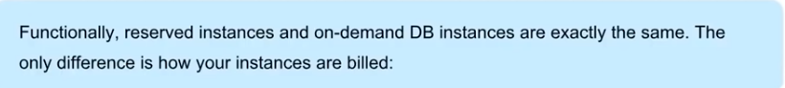

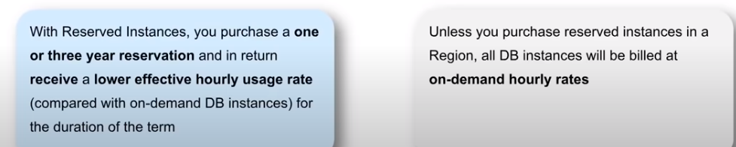

58. Which type of scaling would you recommended for RDS and why?

>>>

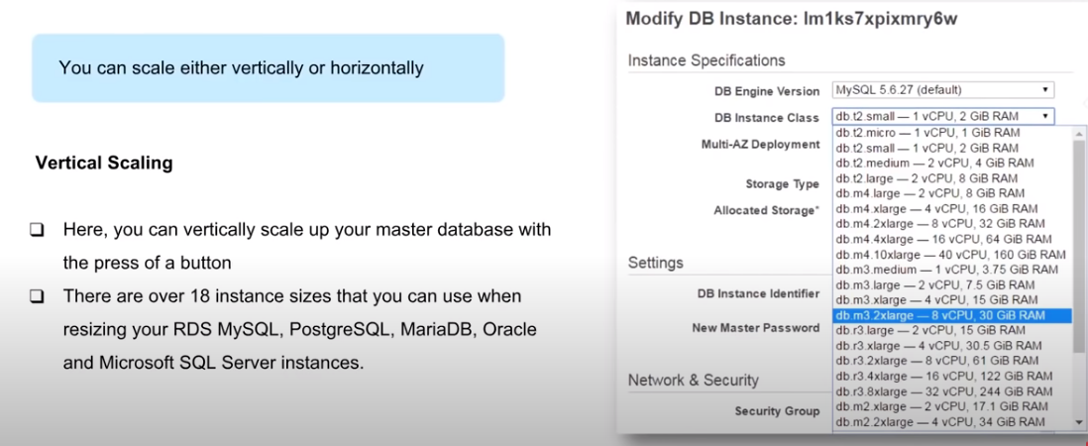

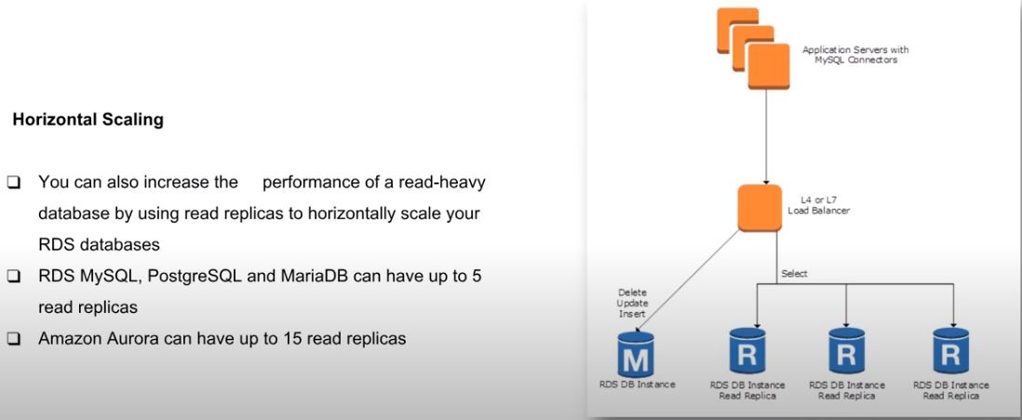

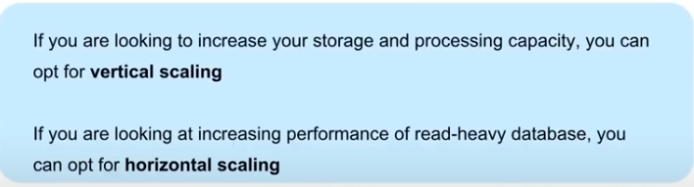

59. 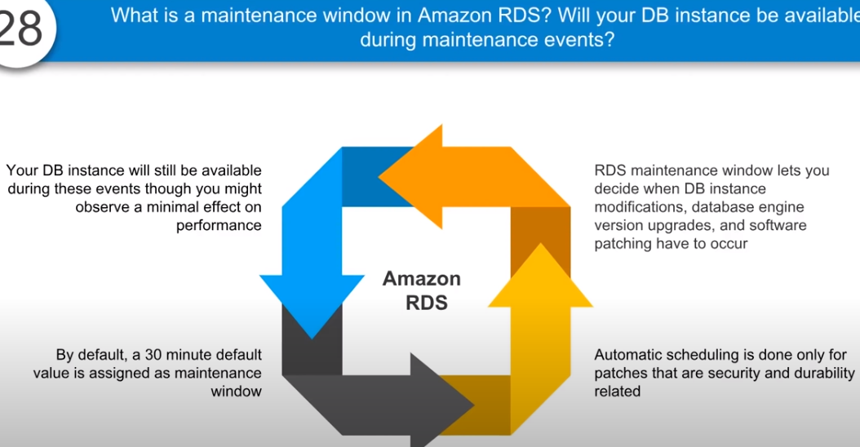

60. What are the consistency models in DynamoDB?

>>>

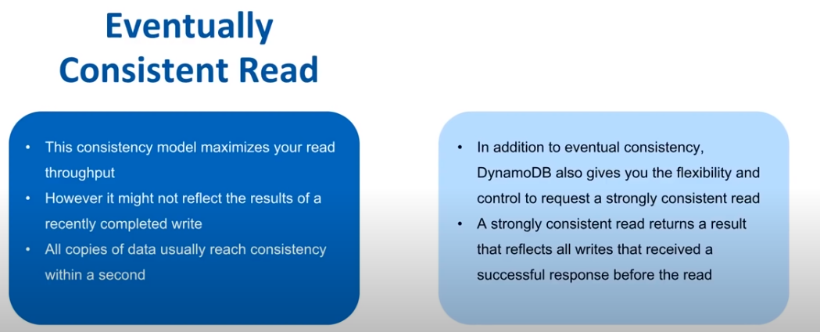

61. What kind of query functionality does DynamoDB Support?

>>>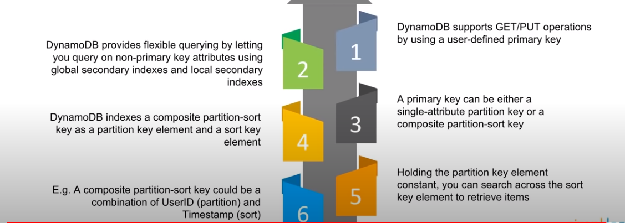

62. 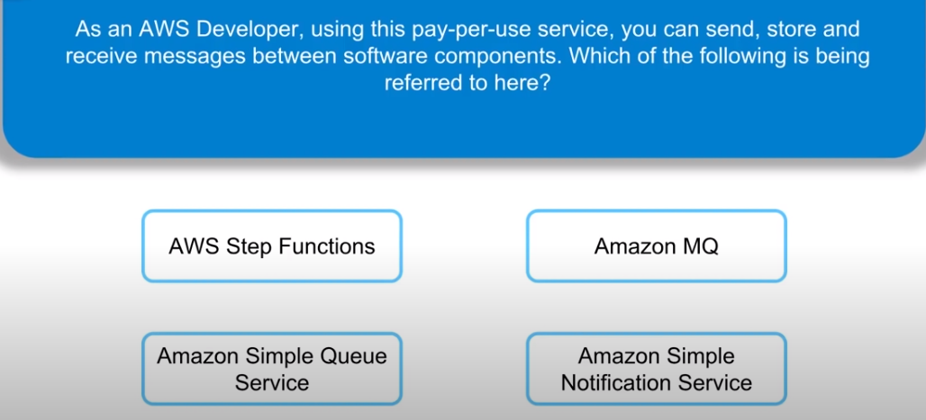

>>> Amazon Simple Queue Service

63. 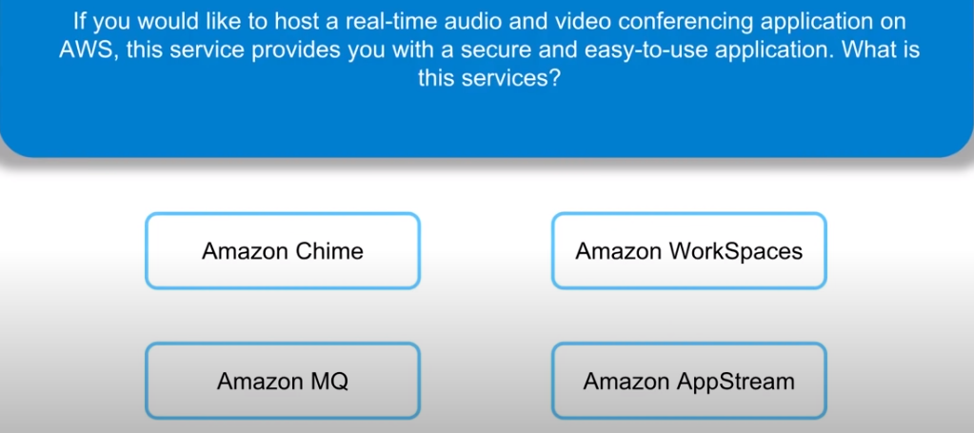

>>> Amazon Chime

64.

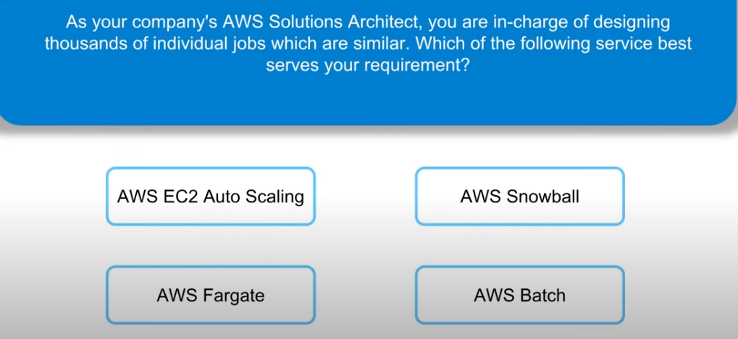

>>> AWS Batch

65.

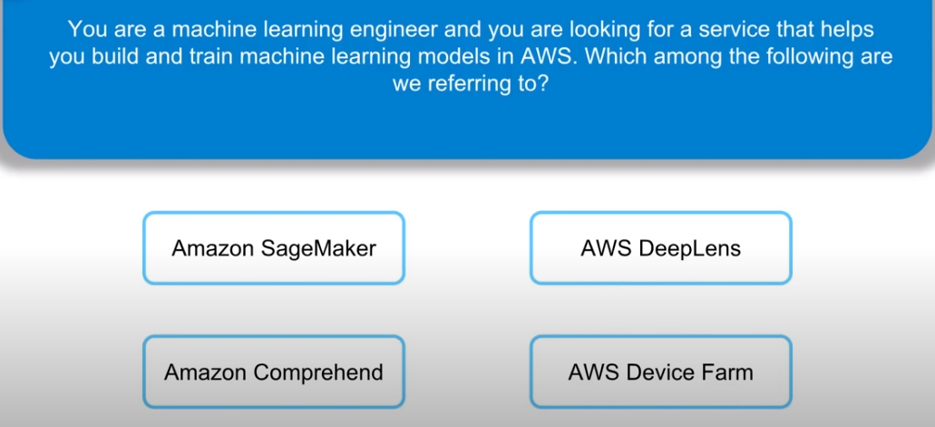

>>> Amazon SageMaker

66.

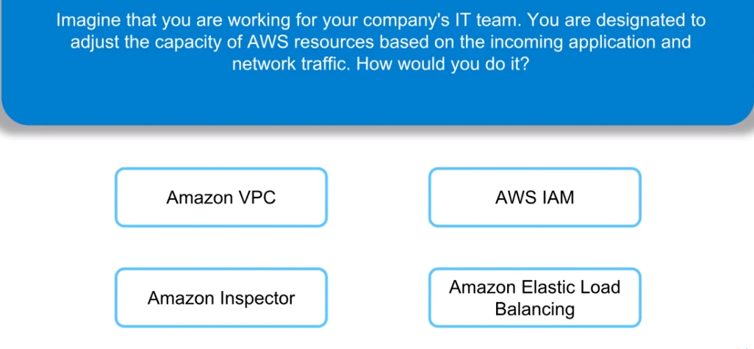

>>> Amazon Elastic Load Balancing

67.

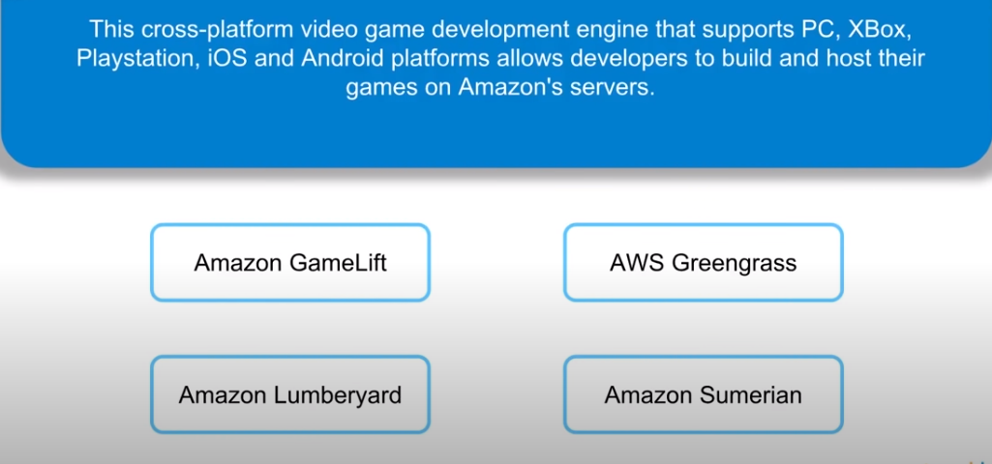

>>> Amazon Lumberyard

68.

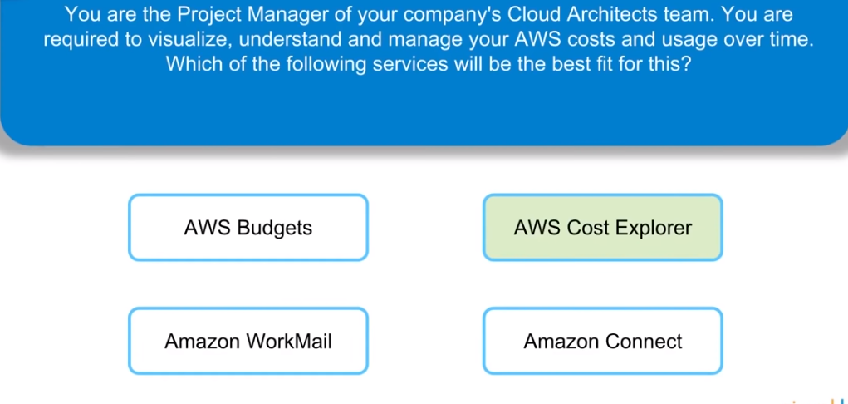

>>> AWS Cost Explorer

69.

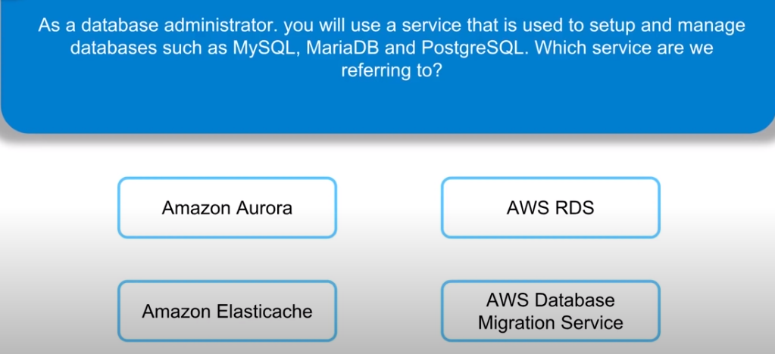

>>> AWS RDS

70.

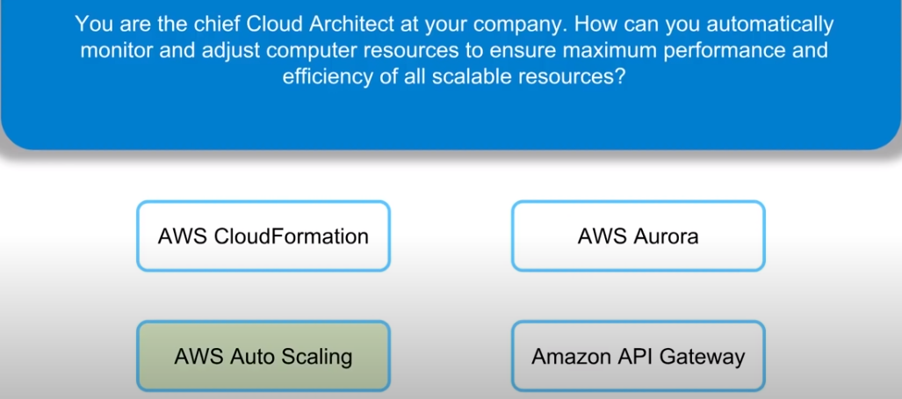

>>> AWS Auto Scaling

71.

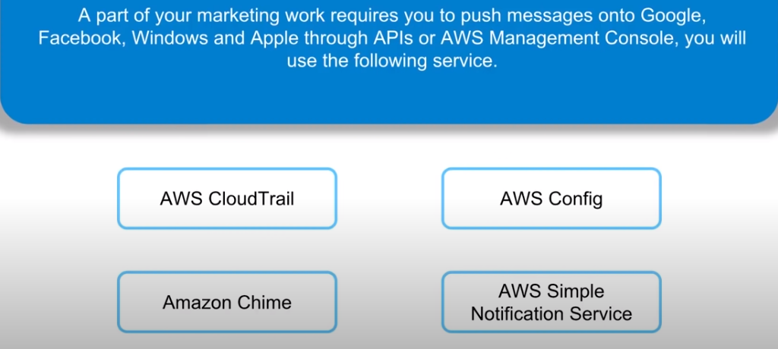

>>> AWS Simple Notification Service